**EV Market**

***“Focusing on the electric vehicle market, particularly the four-wheeler segment, we aim to effectively segment the market to position our product in a category that will generate significant profit.”***

by

Anagha Patil

**Overview**

The electric vehicle (EV) market in India is experiencing rapid growth, driven by increasing environmental awareness, supportive government policies, and technological advancements. Key government initiatives, such as the FAME II Scheme and the National Electric Mobility Mission Plan (NEMMP), aim to promote EV adoption through subsidies and the establishment of nationwide charging infrastructure. Additionally, various state-level incentives further encourage EV adoption. Market segmentation reveals that two-wheelers, including electric scooters and motorcycles, dominate, particularly in urban areas. The four-wheeler segment, comprising electric cars and commercial vehicles, is steadily growing with contributions from both domestic and international manufacturers. The three-wheeler segment, including electric rickshaws and auto-rickshaws, is vital for last-mile connectivity, while the commercial vehicle segment, including electric buses and light commercial vehicles, is driven by public transport and logistics needs. Despite challenges such as inadequate charging infrastructure, high initial costs, and battery technology limitations, the market presents significant opportunities. Continued technological advancements, improved infrastructure, and consumer education will be crucial for unlocking the full potential of the Indian EV market.

In conclusion, the Indian electric vehicle market is poised for significant growth, driven by supportive government policies, rising environmental awareness, and technological advancements. Despite challenges like inadequate charging infrastructure and high initial costs, the market's potential can be unlocked through continued innovation, improved infrastructure, and enhanced consumer education.

**Problem Statement:**

In the context of the Indian electric vehicle market, there is a need to strategically identify and engage with the most lucrative customer segments for our four-wheeler EV offerings. This necessitates conducting thorough segmentation analysis, considering the constraints and availability of diverse data categories, to devise an effective market entry strategy.

**Sales Data:**

Sales data spanning from 2017 to 2024 for electric vehicles has been obtained from the Society of Manufacturers of Electric Vehicles. This comprehensive dataset includes sales data for electric two-wheelers, three-wheelers, four-wheelers, and buses, providing a comprehensive insight into market dynamics and consumer preferences over the specified timeframe.

>> data_e4w = pd.read_excel("2w_data.xlsx", sheet_name=None)

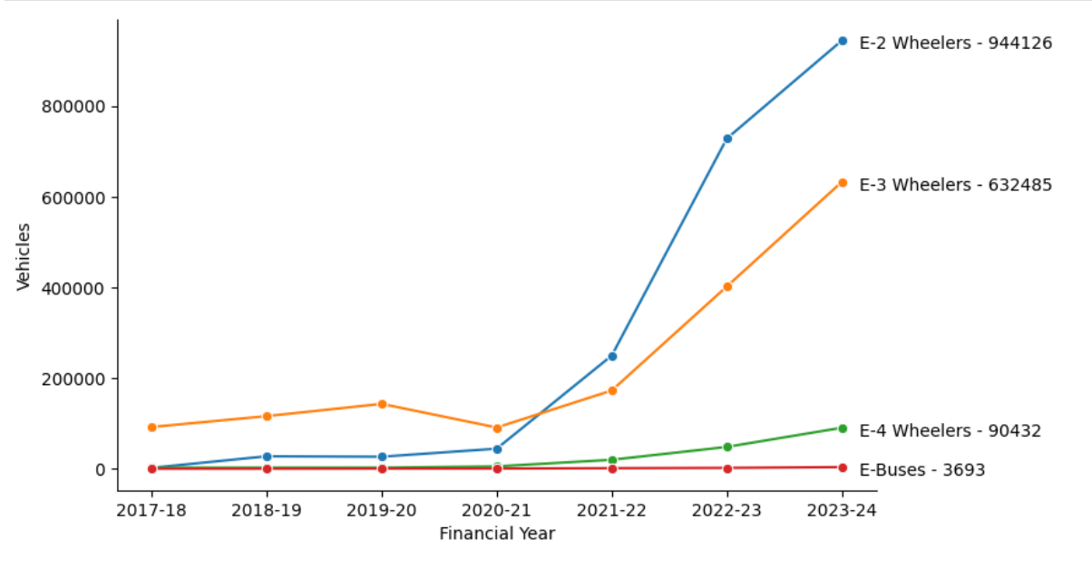

*Fig 1: Electric vehicle sales with respect to financial years.*

In 2024, India's **four-wheeler electric vehicle market** continues to assert its dominance within the industry, boasting a substantial recorded sale of **90,432 units**. This figure underscores the significant growth and adoption of electric four-wheelers in the country, reflecting a burgeoning interest and confidence among consumers in this segment. As electric mobility gains traction, the four-wheeler segment stands out as a key driver of the EV market, offering consumers a viable and sustainable alternative to traditional gasoline-powered vehicles. With its robust sales performance, the electric four-wheeler segment in India reaffirms its position as a pivotal player in the ongoing transition towards cleaner and greener transportation solutions.

* The details of demand incentives provided under the Faster Adoption and Manufacturing of (Hybrid and) Electric Vehicles in India (FAME) scheme Phase-II until October 2022, categorized as follows, are:

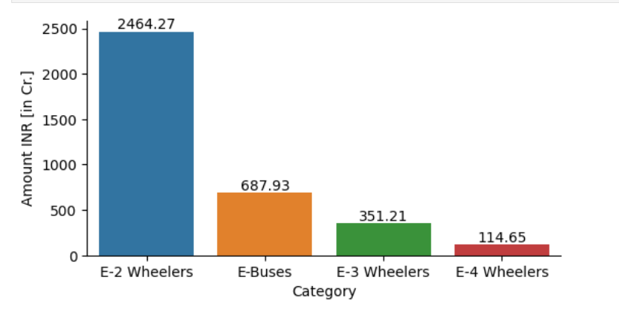

*Fig 2: Incentives provided under the Faster Adoption and Manufacturing of (Hybrid and) Electric Vehicles in India (FAME) scheme Phase-II until October 2022.*

The financial aspect of the electric vehicle market in India is depicted in the above figure, highlighting the industry's total value in crores. Among the various segments, ***four-wheelers accounted for a revenue of 114.65 crores***, as per the Society of Manufacturers of Electric Vehicles 2022 report.

**Analysis and Approaches used for Segmentation:**

**Clustering**

Clustering is one of the most common exploratory data analysis techniques used to get an intuition about the structure of the data. It can be defined as the task of identifying subgroups in the data such that data points in the same subgroup (cluster) are very similar while data points in different clusters are very different. In other words, we try to find homogeneous subgroups within the data such that data points in each cluster are as similar as possible according to a similarity measure such as euclidean-based distance or correlation-based distance. The decision of which similarity measure to use is application-specific. Clustering analysis can be done on the basis of features where we try to find subgroups of samples based on features or on the basis of samples where we try to find subgroups of features based on samples.

**K Means Algorithm**

K Means algorithm is an iterative algorithm that tries to partition the dataset into pre-defined distinct non-overlapping subgroups (clusters) where each data point belongs to only one group. It tries to make the intra-cluster data points as similar as possible while also keeping the clusters as different (far) as possible. It assigns data points to a cluster such that the sum of the squared distance between the data points and the cluster’s centroid (arithmetic mean of all the data points that belong to that cluster) is at the minimum. The less variation we have within clusters, the more homogeneous (similar) the data points are within the same cluster. The way k means algorithm works is as follows:

1. Specify number of clusters K.

2. Initialize centroids by first shuffling the dataset and then randomly selecting K data points for the centroids without replacement.

3. Keep iterating until there is no change to the centroids. i.e assignment of data points to clusters isn’t changing.

The approach k-means follows to solve the problem is expectation maximization. The E-step is assigning the data points to the closest cluster. The M-step is computing the centroid of each cluster.

**Applications**

K means algorithm is very popular and used in a variety of applications such as market segmentation, document clustering, image segmentation and image compression, etc. The goal usually when we undergo a cluster analysis is either:

1. Get a meaningful intuition of the structure of the data we’re dealing with.

2. Cluster-then-predict where different models will be built for different subgroups if we believe there is a wide variation in the behaviors of different subgroups.

**Data Collection:**

This dataset is from carwala.com which offers a comprehensive view of customer perceptions and experiences with electric two-wheelers, enabling businesses and researchers to gain valuable insights into product performance, satisfaction drivers, and areas for improvement in the rapidly evolving electric vehicle market.

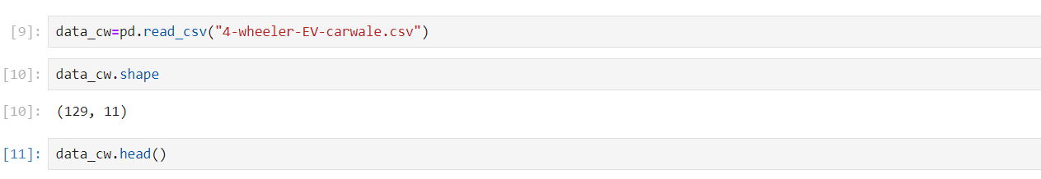

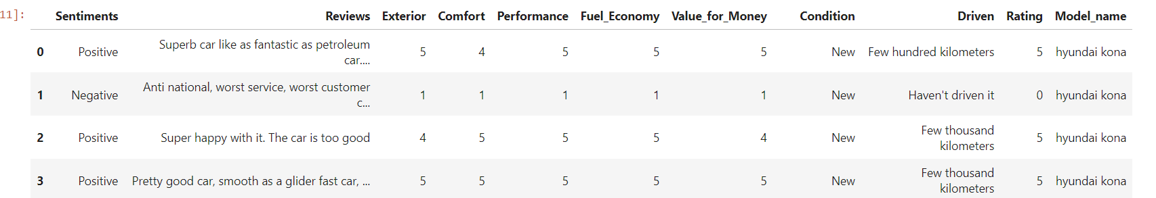

Extracting the most important features that affect the analysis and fill the null values to standardized the data.

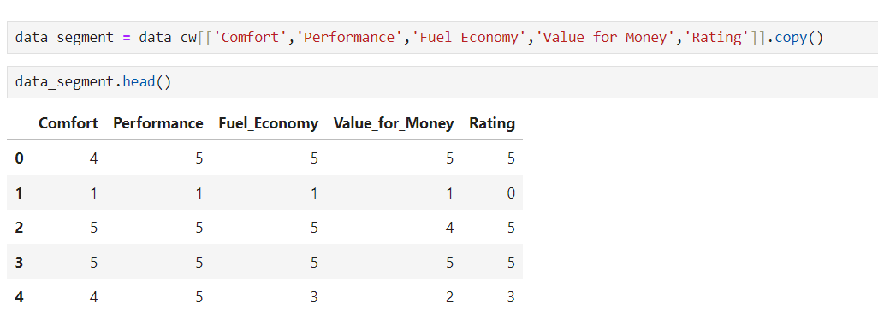

**Segmentation:**

**Using K-means:**

We can use the Elbow method to find the optimum K value.

For this our plot is something like this.

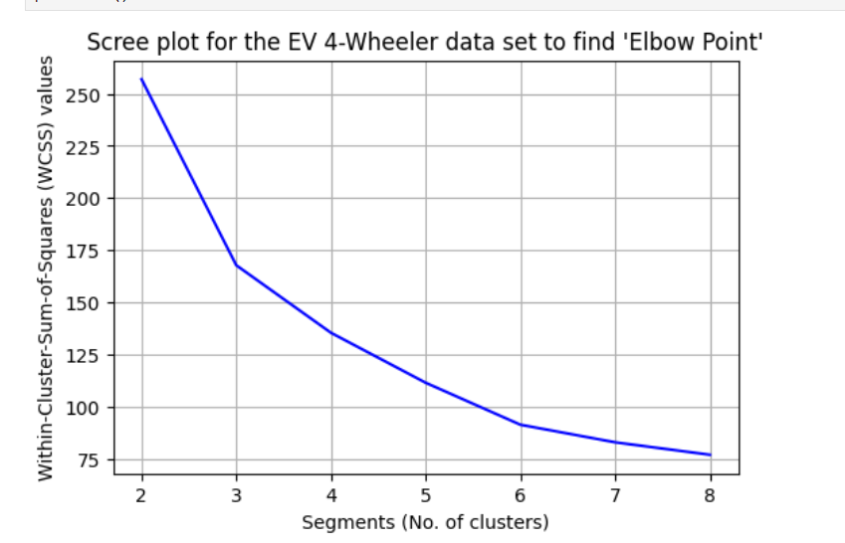

Fig 3: Scree plot to get segmentation.

The decision-making process heavily relied on the insights gained from the scree plot depicted above. It unveiled a noticeable elbow at four segments, indicating a substantial decrease in distances. This pivotal point suggested the optimal number of segments for our analysis.

**Profiling Segment:**

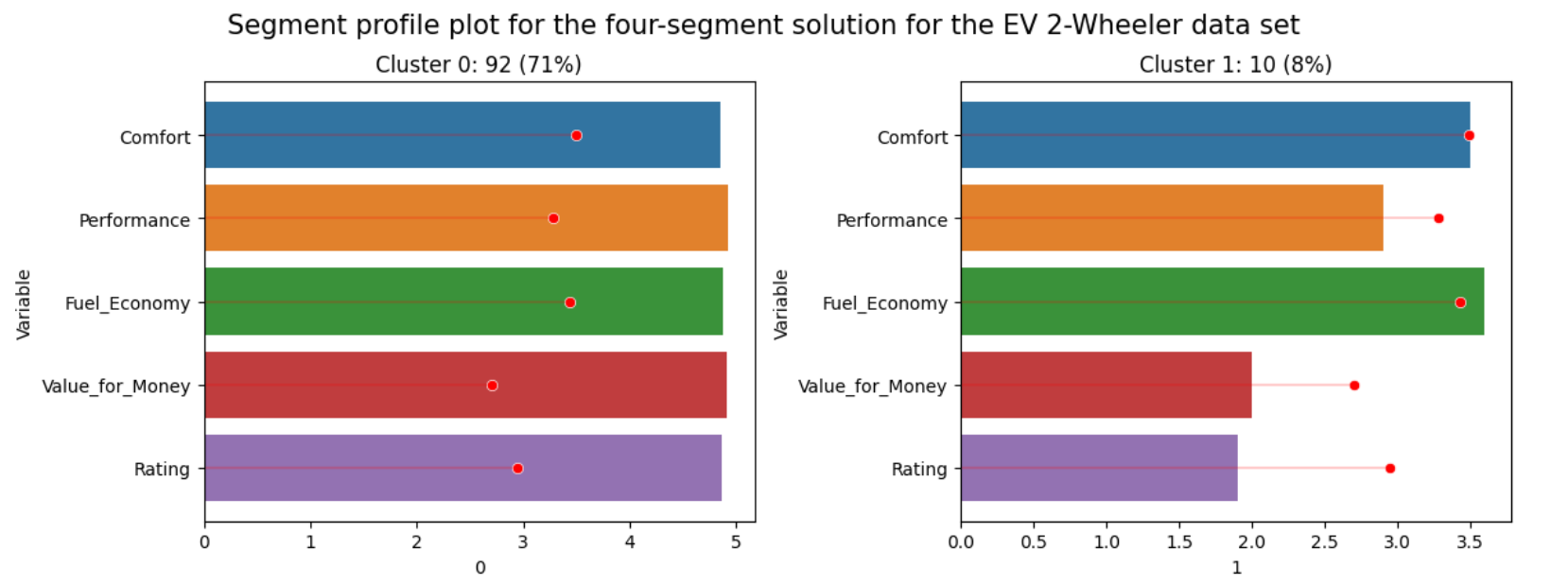

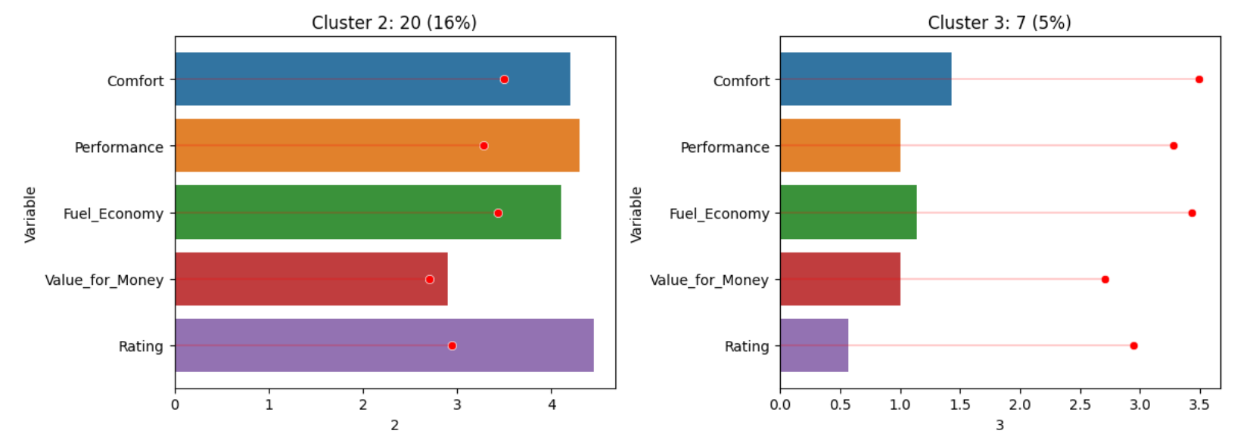

The visualization above illustrates the diverse perspectives across different segments. Segment 0, representing 71% of consumers, shows a strong appreciation for comfort, performance, fuel economy, value for money, and overall rating. Similarly, Segment 1, accounting for 8% of consumers, exhibits high regard for these factors, with a particular emphasis on value for money. Segment 2, comprising 16% of consumers, also values comfort, performance, fuel economy, value for money, and rating. However, Segment 3, representing 5% of consumers, expresses dissatisfaction across these aspects, indicating the need for improvement to address their concerns. This segmentation sheds light on distinct consumer perceptions, particularly regarding product features and satisfaction levels.

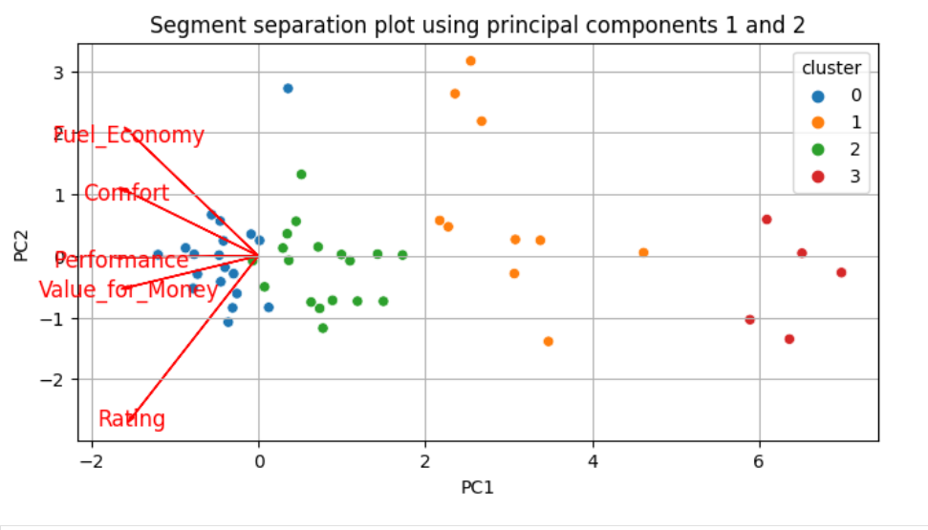

The segment separation plot reveals distinct clustering patterns based on principal components 1 and 2. Cluster 0 (blue) and Cluster 2 (green) are densely packed around the origin, indicating balanced attributes without extreme values. Cluster 1 (orange) and Cluster 3 (red) are spread along the PC1 axis, suggesting significant variation in performance and value for money, with Cluster 3 showing the most distinct differentiation. The attribute vectors indicate that fuel economy and comfort are positively correlated with PC2, while performance and value for money are positively correlated with PC1.

**Describing Segment:**

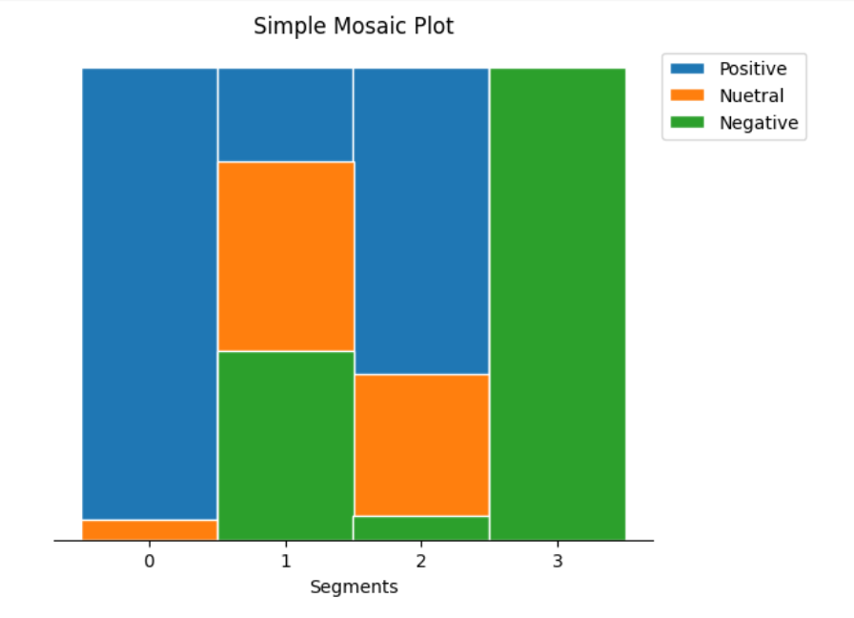

The mosaic plot below highlights consumer sentiments across different segments. Segment 0 is predominantly positive, with very few neutral or negative sentiments. Segment 1 shows a mix of sentiments, with significant positive, neutral, and negative feedback. Segment 2 has a majority of positive sentiments but also a notable amount of neutral responses. Segment 3 is split, with a substantial portion of both positive and negative sentiments. This analysis reveals diverse sentiment patterns, indicating varied consumer satisfaction and preferences within each segment.

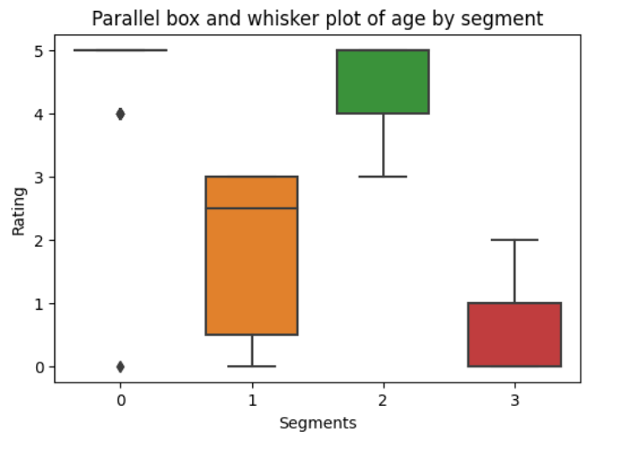

The parallel box and whisker plot above highlight substantial differences in average ratings among segments. Particularly, consumers in Segment 3 exhibit dissatisfaction across all perceptions, resulting in lower overall ratings. This visualization underscores the varying perceptions and satisfaction levels among different segments of consumers.

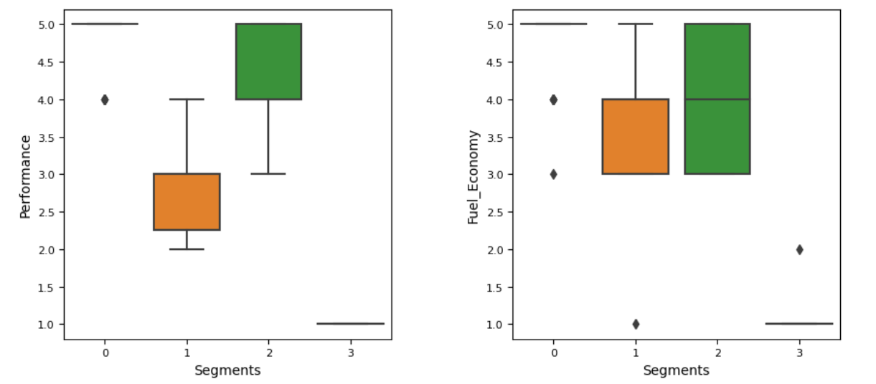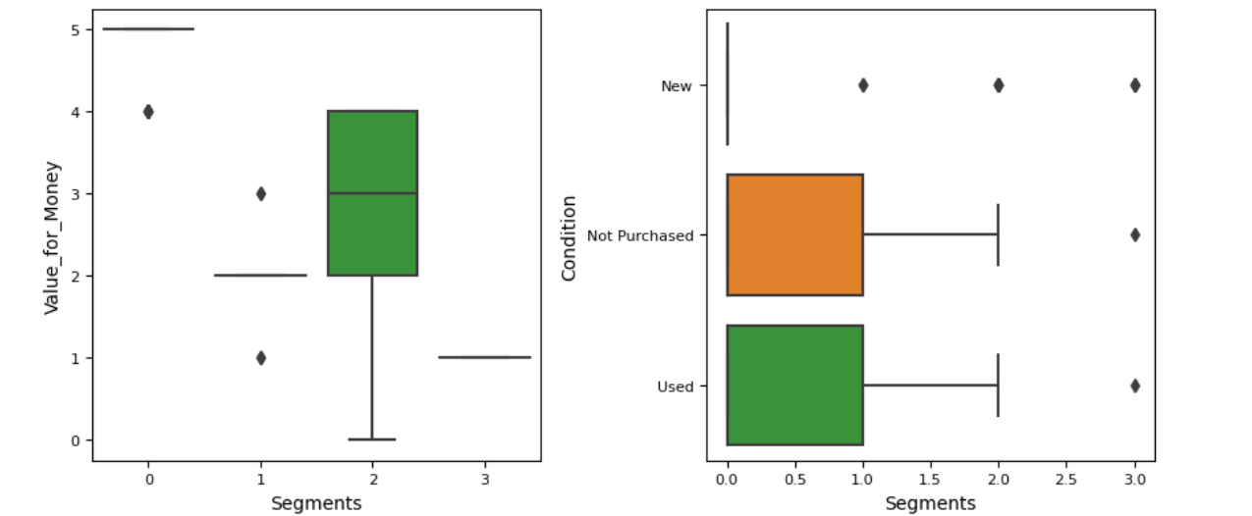

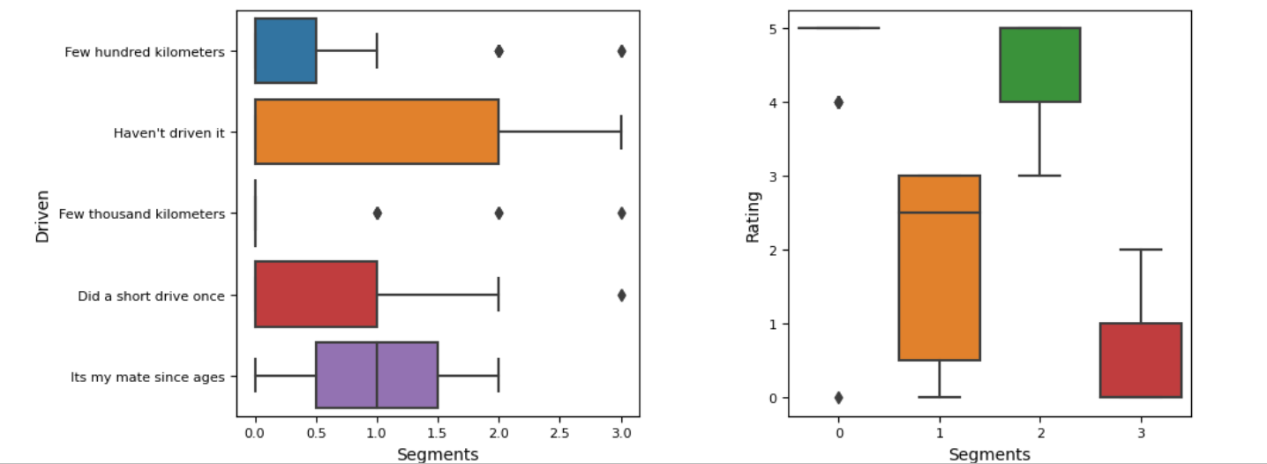

The analysis of electric vehicle (EV) technical specifications across different segments in India reveals distinct market trends and preferences. Segment 2 dominates the premium, long-range EV market, achieving high customer satisfaction and indicating a lucrative niche for luxury and long-distance EVs. In contrast, Segment 3 targets budget-friendly commuter EVs but shows lower satisfaction, suggesting areas for enhancing the driving experience. Segments 0 and 1 focus on affordability, with varied charging time preferences and mixed satisfaction, highlighting the need to balance cost and performance to boost consumer satisfaction.

**Selection of Target Segment:**

In the electric vehicle market, the strategic focus lies on two key segments: Segment 0, representing 71% of consumers, and Segment 2, representing 16% of consumers. Segment 0 prioritizes comfort, performance, fuel economy, and rating, suggesting an opportunity to tailor electric vehicles to meet these preferences while emphasizing their value for money. On the other hand, Segment 2 exhibits similar performance on various parameters, offering a chance to enhance customer satisfaction and loyalty by directly addressing their specific needs. By targeting the comfort, performance, and value for money of a product in both Segments 0 and 2 and amplifying the positive aspects in these segments, the strategy aims to align electric vehicles with the unique expectations of each segment, thereby securing a competitive edge and fostering continuous market expansion.

**Customizing the Marketing Mix:**

In our electric vehicle market strategy, the customization of the marketing mix plays a pivotal role in appealing to our target segments, Segment 0 and Segment 2. Both segments share similarities but have major dissatisfaction regarding value for money. Here is a tailored marketing mix that addresses these issues and focuses on key features such as comfort, performance, fuel economy, value for money, and rating.

**Product Customization.**

**Segment 0 (71% of consumers):**

* Comfort and Performance: Enhance interior features such as ergonomic seating, advanced climate control, and superior driving dynamics.
* Fuel Economy: Integrate energy-efficient technologies to extend battery life and reduce operating costs.
* Rating: Ensure high safety ratings and positive reviews by incorporating advanced safety features and reliable performance.
* Value for Money: Offer packages that bundle these features at a competitive price point, providing clear value propositions.

**Segment 2 (16% of consumers):**

* Comfort and Performance: Focus on providing a premium feel with luxury interiors, high-end materials, and top-tier performance specs.
* Fuel Economy: Highlight cutting-edge technology that optimizes energy consumption and extends driving range.
* Rating: Strive for excellent ratings through rigorous quality control and superior customer service.
* Value for Money: Introduce value-added features such as free maintenance for a certain period, loyalty rewards, and additional services that justify a slightly higher price point.

**Conclusion:**

In conclusion, our extensive analysis of India's electric vehicle market has led us to pinpoint Segment 0 as the ideal target. With a substantial 71% share of consumers, this segment presents a significant market opportunity. By customizing our electric four-wheeler specifications to cater to the preferences of this segment, we guarantee that our products seamlessly align with the needs of a large customer base. This strategic choice is informed by a comprehensive understanding of market segmentation, consumer behavior, and technical requirements. These insights provide clear guidance for our market entry, emphasizing accuracy and relevance in both product development and marketing strategies. Going forward, this approach provides us with a solid footing, ensuring that our offerings resonate effectively within the dynamic landscape of India's electric vehicle market.